Invites you to a public meeting for the upcoming construction project on US-31
from 3 Mile Road to the Grand Traverse Resort

When: Wednesday, March 25, 2015 5:30 pm to 7:00 pm

Where: East Bay Township Hall, 1965 N 3 Mile Road, Traverse City, MI

The Michigan Department of Transportation (MDOT) will have a public meeting to discuss reconstruction of US-31/M-72 between 3 Mile and Holiday roads in East Bay Township, and resurfacing US-31 from Holiday Road to the Grand Traverse Resort in Acme Township.

Work is currently scheduled to begin in April along the roadway from 3 Mile Road to Holiday Road and includes full replacement of the roadway with curb and gutter removals and replacements, drainage improvements and the interconnection of the sidewalks. Resurfacing from Holiday Road to the Grand Traverse Resort will take place after Labor Day.

Two-way traffic will be maintained and access to adjacent properties will be accommodated at all times.

For more information on this project contact MDOT: Traverse City Transportation Service Center (TSC) (231) 941-1986 or 888-457-MDOT.
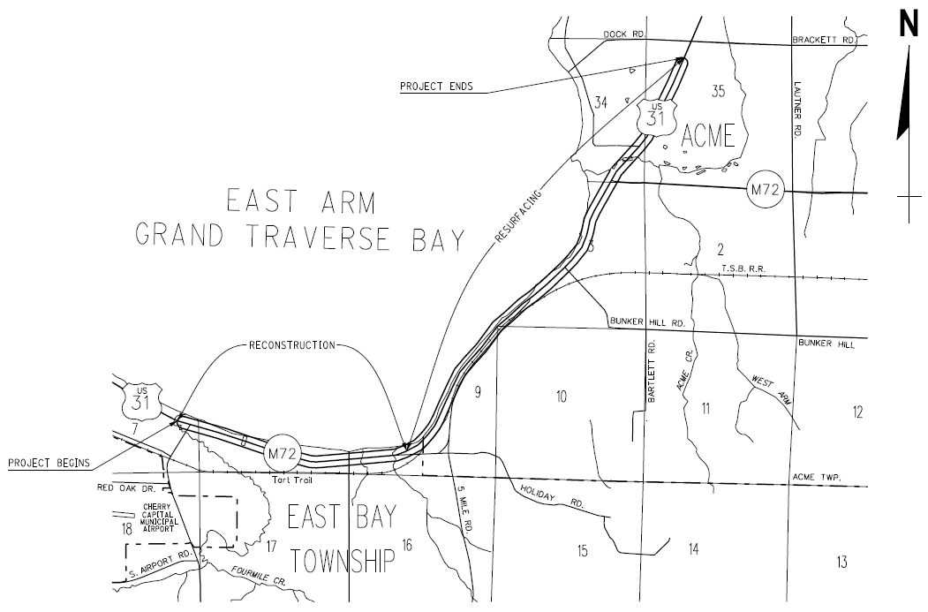

Special Accommodations, please contact David Pax at 231-941-1986 at least two days in advance. If you know of anyone that did not receive a notice but should have, please feel free to pass along this information.

