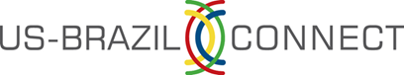

**2015 Community College FELLOWSHIP**

Information Packet

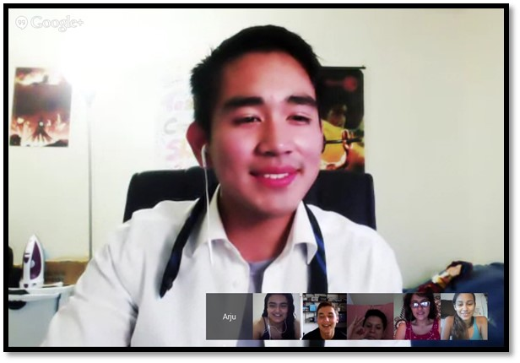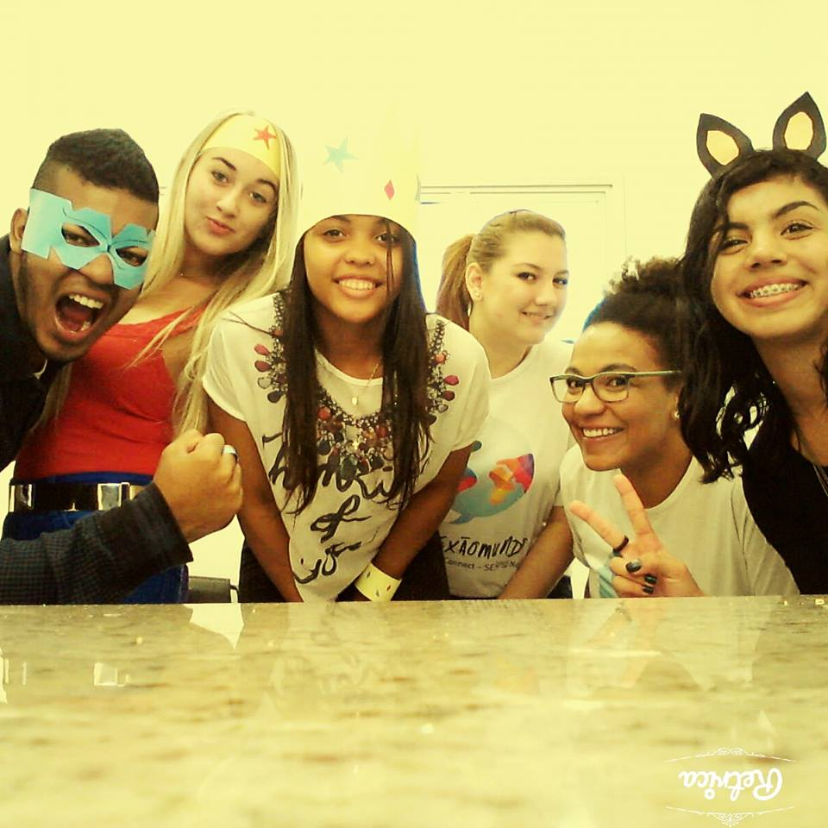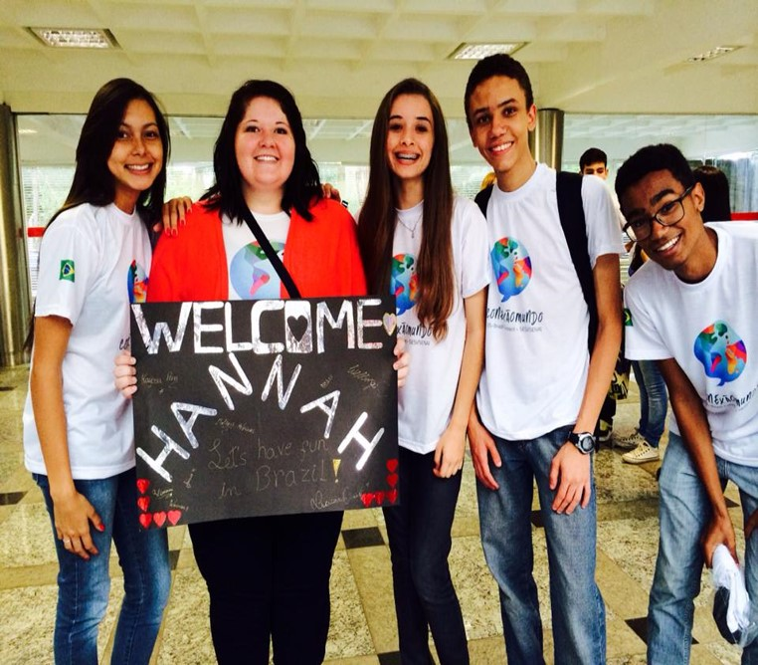

**Application Deadline: November 30, 2014**

**Table of Contents**

**Program Information**

Program Overview……..................................................................................Page 3

Fellowship Role ..........................................................................................Page 4

Why Brazil? ...............................................................................................Page 5

Brazilian Partners………………………………………......................................................Page 5

Program Approach.......................................................................................Page 6

Qualities of Successful Fellows ......................................................................Page 7

Fellowship Benefits & Financial Commitments…................................................Page 8

Fellowship Qualifications……..........................................................................Page 9

Program Dates ………………………………………………………………….…………………………………..…Page 9

Application Process………………………………………………………………………………………………….Page 10

Next Steps………………………............................................................................Page 10

Additional Resources..................................................................................Page 10

**US-Brazil Connect seeks exceptional Community College students to join the 2015 Fellowship Program**

**Program Overview**

US-Brazil Connect is a Denver-based nonprofit organization that strives to strengthen education and build economic opportunities by connecting communities, engaging leaders and creating transformative learning experiences linking the United States and Brazil. In 2014, US-Brazil Connect sent nearly 200 American fellows and team leaders to Brazil to work with local high school students in the Conexão Mundo (World Connection) program. The organization will continue to grow and expand in 2015.

US-Brazil Connect works across multiple sectors and engages diverse partners in order to achieve its mission. In addition to collaborating with the Brazilian Confederation of Industry (CNI) and its SESI/SENAI school systems, the organization has created a working [consortium](http://www.us-brazil.org/what-we-do/community-college-partnerships) of community colleges throughout the United States. By engaging community colleges in delivering the Conexão Mundo program, US-Brazil Connect supports dynamic leadership opportunities for community colleges students and strengthens community college capacity for creating international programs.

We are looking for strong fellowship candidates who have the drive and desire to thrive in the US-Brazil Connect [2015 Fellowship Program](http://www.us-brazil.org/get-involved/us-fellowship-opportunities).Fellows will be part of an innovative international education initiative designed to help Brazilian high school students strengthen their confidence and skill communicating in English. After an initial training period, fellows serve as English coaches to Brazilian students for a total of 18 weeks. Fellows develop a mentoring relationship with their assigned students through online platforms and in-person classroom time. In addition, fellows train, prepare, and give and receive support with members of their US-Brazil Connect team.

**In this Fellowship, community college students:**

* **Partner in responsible international development:** In direct contrast to charity projects, this Fellowship is part of a mutually-beneficial collaboration between US-Brazil Connect and its Brazilian partners.
* **Strengthen global leadership skills:** Through training, practical experience and reflection, fellows develop and sharpen leadership skills applicable to working on teams, facilitating groups, mentoring youth, understanding innovative education design, and contributing to dynamic cross-cultural environments.
* **Work directly with Brazilian high school students:** Working as English language “coaches” with Brazilian students via social media and in-person formats, fellows are part of an international education initiative.
* **Travel to Brazil:** Traveling as representatives of US-Brazil Connect and their participating college, fellows work in Brazil at their assigned site for 4 weeks of this 6-month fellowship.

**Fellowship Role**

In the Community College Fellowship program, teams are comprised of fellows from the same college plus 1 to 2 US-Brazil Connect team leaders. This fellowship is a transformative global learning and leadership experience. This is a working fellowship that is both rigorous and rewarding! For a fellowship job description, please visit our [website.](http://www.us-brazil.org/get-involved/community-college-potential-fellows)

* **Training**: Actively participate in a rigorous training program that combines online and in-person modules. Training consists of one weekend workshop and 5 Saturday online sessions, combined with weekly online assignments with your team of US-Brazil Connect fellows. The emphasis is on leadership development, teamwork, and coaching skill development for facilitating English as a Foreign Language (EFL) activities. The preparation period also examines Brazilian culture and prepares fellows for travel to Brazil.
* **Online Coaching:** Serve as an online coach to support Brazilian students’ developing confidence in communicating in English. Fellows are required to spend a minimum of 4-5 hours per week online with students via Facebook and Google Hangout. Online coaching of Brazilian students is required for 8 weeks prior to travel to Brazil and for 6 weeks following return. US-Brazil Connect provides support and guidance for engagement with students.
* **Leadership Development:** Fellows are required to spend at least 2 hours per week completing their weekly fellowship assignments, completing self-evaluation and student evaluation reports and other tasks as required. Fellows must be able to consistently commit at least 6 hours per week to the fellowship.
* **Travel**: Fellows travel to Brazil for a 4-week period. Travel dates and site assignment will be determined after enrollment into the fellowship.
* **In-Person Coaching:** In Brazil, fellows interact with their Brazilian students for 4 to 6 hours per day, leading 2 different groups of students, assisting with daily assemblies, attending field trips with students, and working as a collaborative team member with other fellows and the team leaders. Fellows should also plan to spend 1-2 hours daily for team meetings and lesson planning. The experience in Brazil is intense and challenging. All participants should expect a full and demanding schedule during this time. Weekends are generally free to explore the community.
* **Giving Back:** Upon return, fellows will be required to complete a “Pay-it-Forward” project to give back to their college or community through speaking, writing or other service projects.

*“I never imagined in a million years that I would get to be a part of such an awesome experience… I am sure I will take the lessons from this summer with me for the rest of my life… The program helps shape who you are as a person, and working in Conexao Mundo is one of those stories I would love to tell my grandchildren about”.*

*---Miami Dade College fellow*

**Why Brazil?**

Brazil is emerging as a key global economic player. Ten years ago, economists identified 4 countries that were poised to emerge as major economic forces in the global economy:  Brazil, Russia, India, and China.  Today, Brazil is the world’s 7th largest economy and per-capita income is nearly twice that of China. Brazil’s rise is projected to continue with the recent hosting of the 2014 World Cup and the upcoming 2016 Olympics. In 2007, oil deposits in the Atlantic Ocean were confirmed to hold enough oil to turn Brazil into one of the world’s top five crude oil producers.

Most importantly, from 2003 to 2008, over 27 million people in this country of 200 million have moved from poverty into Brazil’s middle class. Due to the increasing purchasing power of a growing middle class, Brazil is projected to become the fifth largest consumer market by 2030, ahead of the UK and France. Brazil is already the world’s third largest market for mobile phones, the fifth largest for vehicles and computers, and the eighth largest for higher education.

Given the emerging role of Brazil as an economic power and a source of innovation and creativity, it is imperative that American organizations and colleges prepare students for meaningful engagement with Brazil. Our fellowship provides this opportunity!

**Brazilian Partners & Conexão** **Mundo**

[Conexão Mundo](http://www.us-brazil.org/what-we-do/conexao-mundo) is a unique collaboration between US-Brazil Connect and the Brazilian Confederation of Industry (CNI) and its SESI/SENAI school systems. CNI is the pre-eminent Brazilian business association, with over a thousand employer associations across all 26 states of Brazil, as well as more than 100,000 member organizations. Supported by a 2.5% payroll tax, the Confederation operates the SENAI and SESI education and training system which comprise the largest technical training network in Latin America, enrolling over 7 million students annually in about 800 schools and technical institutes throughout Brazil.

CNI is investing in this partnership as a means to support English language training for their students, thereby strengthening the Brazilian workforce to meet the demands of a rapidly growing economy. US-Brazil Connect’s approach—focused on relationships and empowerment—has had tremendous impact on our participants and is customized for our partners at CNI.

The jointly implemented international education initiative aims to fulfil 3 objectives:

1. Strengthen the English language skills and confidence of Brazilian high school students
2. Provide transformative learning experiences for US college students and young professionals
3. Build capacity for exchange between US community colleges and Brazilian technical institutions

**Program Approach**

Prior to Conexão Mundo, many participating Brazilian students studied some English in grammar-based classrooms. However, the majority of students had never met or communicated with a foreigner, especially a native or near-native English speaker. For these students, attitude, not skills, was their greatest barrier to communicating in English.

Despite ranging academic knowledge of the language, students may be nervous, shy, or even afraid to have a conversation in English. Additionally, when students have never met people from other countries, the value of being able to communicate in another language can be abstract.

The educational framework, developed by US-Brazil Connect with the support and input of its Brazilian partners, is asset-based. It is designed to help students overcome fear, take risks, grow, have fun with the learning process, build relationships with everyone involved, and expand their knowledge of career pathways.

US-Brazil Connect fellows serve in this model as English coaches – not teachers. Their job is to help students build confidence communicating in a different language. Through coaching, fellows are also challenged to overcome fear, take risks, grow, and build relationships. The program’s transformative power depends on the shared responsibility of Brazilian students and US coaches.

To learn more about the Fellowship from the perspective of program alumni, visit our [website](http://usbc.enviemedia.com/fellow-stories).

“I experienced a new culture that gave me a new perspective on things... I learned a lot about myself and gained leadership skills, public speaking skills and traveling skills. I had to be patient, flexible and willing to do things that may have been out of my comfort zone in the US. Truth be told, I found a part of me that was hidden, and that part of me is here to stay!”- Northwestern Michigan fellow

**Qualities of Successful Fellows**

We are looking for community college students who will contribute to the success of their team. Characteristics of successful fellows include:

* **Being a Creative Partner:** This is not an experience to be ‘consumed.’ Candidates applying to the program should be ready to actively work, learn, reflect, give and grow throughout this experience. The true value of this experience can only be experienced when a fellow gives their time, energy and heart.
* **Resourceful:** fellows are flexible, adaptable, patient and ready to make the most of whatever challenges come their way.
* **Team-oriented:** Fellows are able to focus on the goals of the team, collaborate effectively with other team members, and devote the effort necessary to achieve team success.
* **Comfortable with technology:** Fellows are familiar with social media tools or are willing and able to quickly learn. They are interested in connecting with others through the digital divide.
* **Reflective:** Fellows are willing to share information, perceptions, and feedback openly while continually striving for growth.
* **Optimistic:** Fellows believe that a better world is possible and seek to understand what role they can play in contributing to positive change.

* **Principled:** Fellows possess maturity and the ability to commit to a goal larger than themselves.
* **Culturally Aware**: Fellows understand that each culture is unique. They appreciate diversity and are eager to learn and share across cultures.

**Fellowship Benefits & Financial Commitments**

**Benefits***:* This program offers many resources to fellows. Benefits include:

* **In-Country Resources***:* US-Brazil Connect’s partners support fellows by providing local coordination that includes: accommodations at a hotel, meals or a meal allowance, local transportation to the school site, and local health insurance for the 4 weeks in Brazil.
* **Modest stipend and program certificate:** Upon successful completion of the Fellowship, fellows will receive a stipend and certificate. The stipend is approximately $600, depending on the current exchange rate.
* **College Support:** Each community college in the Consortium pays an annual membership fee and per fellow training fee.
* **Mentoring & Leadership Development*:*** Fellows receive mentoring and support from our trained team leaders that focus on professional development and coaching skills. Our fellowship curriculum is designed to cultivate leadership and cross-cultural skills so participants learn and grow throughout each phase of the program. Fellows gain experience working with both Americans and Brazilians teams in an international setting.

Benefits of the Fellowship are valued at over $8,750 per individual.

**Financial Commitments***:* Although this program is very affordable, it is not “all-inclusive”. Fellows are responsible to pay:

* **Travel Costs:** This includes the cost of a passport, an international flight to Brazil and the cost of a Brazilian visa. Flight prices vary based on departure and arrival locations, but may range from $1,500- $2,000. A Brazilian visa typically costs $250 (including service charge) and is valid for 10 years.
* **Health Care**: This includes any necessary vaccinations and health insurance coverage. Vaccination costs will vary based on individual’s health insurance coverage and recommendations from their personal care physician. US-Brazil Connect requires selected fellows to follow the vaccination guidelines issued by the [Centers for Disease Control and Prevention](http://wwwnc.cdc.gov/travel/). We require that Fellows purchase emergency evacuation coverage at a minimum of $50,000. This typically costs $50-100.
* **Spending Money:** Personal costs while in Brazil, such as choosing to eat out in restaurants, souvenirs/gifts, weekend excursions, etc.
* **Tuition:** Costs associated with earning college credit for this fellowship. This differs by college.

**Fellowship Qualifications**

* Genuine interest in cross-cultural exchange: learning about Brazil and connecting with Brazilian high school students while sharing American culture and life experiences
* Commitment to personal growth and developing skills in global leadership
* Commitment to serving as an online and in-person coach to Brazilian students
* Ability to access necessary technology (computer with reliable internet connection, webcam and microphone) several times per week
* Ability to consistently dedicate a minimum of 8 hours per week to the fellowship in Phase I and Phase III (4-5 hours of direct coaching to students, 2-3 hours on fellowship assignments, student evaluations, other tasks as assigned). There will be a greater time commitment in weeks with the Saturday morning online training session and weekend workshop.
* Willingness to commit at least 6 hours per day to the program in Phase II (includes time at the school and planning time/team meetings).
* Ability to use online tools and social media platforms including Facebook, Google Hangout video chats, Google Drive, and other applications
* Comfortable leading small groups independently and facilitating group activities
* Ability to complete all aspects of training, including attending five Saturday meetings online and one in-person weekend-long workshop on a designated weekend in April or May 2015
* Respectful of cultural diversity and eagerness for a cultural immersion experience
* Ability to work cooperatively in a team and maintain a positive attitude
* Possession of excellent reading, writing, and speaking skills in English
* Flexibility to live and work in Brazil for 4 weeks at an assigned sites. Site assignments range from thriving urban centers to remote rural areas
* Ability to represent US-Brazil Connect and your college to Brazilian institutional partners, Brazilian students, and the broader community during the Fellowship

No teaching experience or Portuguese skills are required; individuals in the US with a wide range of backgrounds are encouraged to apply.

**Program Dates**

US-Brazil Connect and the Brazilian Confederation of Industry are currently selecting Brazilian sites for the program. Distribution of participating Brazilian states and their availability to host will dictate exact program dates. All sites will be selected by the end of February 2014 and all program dates will be established once the college team is matched with a host site.

Established Program Dates:

* Application Deadline: November 30, 2014
* Fellowship Candidate Interviews: December 2014
* Announcement of Selected Fellows: January 19, 2015
* Deadline to purchase airline tickets to Brazil: March 2, 2015

The 4-week in-person phase in Brazil will take place between June and August of 2015. US-Brazil Connect is working with each college partner to ensure that program dates and college schedules are compatible.

**Application Process**

Community College Fellowship applicants must be currently enrolled with one of our 6 college partners in order to apply. Please contact your [college representative](http://www.us-brazil.org/get-involved/community-college-potential-fellows) for an application and details on the selection process. The application period runs from October 15 to November 30, 2015.

**Next Steps**

If you are selected, your next steps are:

* Apply for a passport immediately if you don’t already have one, or if it expires before December 2015
* Complete the US-Brazil Connect Fellowship enrollment paperwork
* Save funds for purchase of an airline ticket. The college will coordinate flight purchases.

**Additional Information**

To learn more about US-Brazil Connect and our partners, check out these websites:

* [www.us-brazil.org](http://www.us-brazil.org) (our new website!)
* <http://www.cni.org.br/portal/data/pages/FF80808121B629230121B62A6F4A0432.htm>
* <https://www.facebook.com/usbrazilconnect.org>
* <https://twitter.com/USBrazilConnect>

**Thank you for your interest in the US-Brazil Connect 2015 Fellowship.**

**Good luck with your application process.**

**APPLICATION DEADLINE: November 30, 2014**

“This was one of the most positive and exciting experiences of my life. Sometimes I feel like it was all a dream. Being in Brazil felt so comfortable and yet every day I was exposed to something new to learn about the culture... It's hard to put into words, but even in just a short amount of time, I felt like I learned so much about traveling, working in a team, leading, and teaching.” –Community Colleges of Spokane fellow