

**Community College Fellowship: 2014 Alumni Perspective**

If you are considering the 2015 Fellowship, check out these resources to learn more about the opportunity directly from other community college students who completed the program in 2014. Their insight and experiences help communicate the mission and vision of our work!

**Videos**

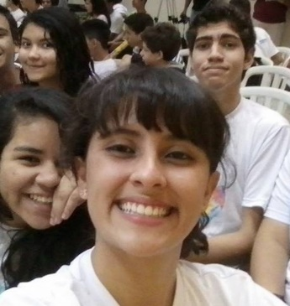Maria, a 2014 Miami Dade fellow has created a short [video](https://www.youtube.com/watch?v=5DC8OMWtYUE) on her experience in Porto Velho, Rondonia. She interviewed other fellows and used photos and videos to capture their story.

“Before the trip, I felt nervous and excited….Students are so excited to meet you. They are so happy that you are there!”

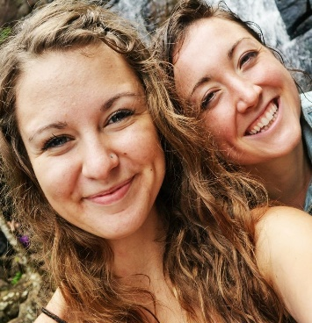

Brook, a 2014 Community Colleges of Spokane fellow created a [video](https://www.youtube.com/watch?v=D1ec7SnyCgE&feature=youtu.be) on her team’s experience in Vila Velha, Espirito Santo.

“This video depicts what made this experience the best time of my life!”

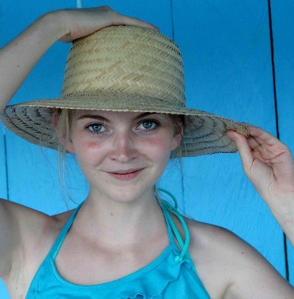Krista, a 2014 Kirkwood Community College fellow created a [video](https://www.youtube.com/watch?v=xzuvtm2n7ew&feature=youtu.be) based on her experience in Macapa, Amapa. Watch Krista explain how applicants can overcome perceived obstacles to be successful in the program.



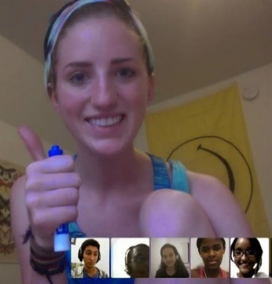**Presentations**

Isabelle, a 2014 Northwestern Michigan College fellow, shares a [presentation](https://docs.google.com/presentation/d/1gmXRdfmbs4xMIKrz6UMB5DHu5X75KSho_2bFk6KV9qg/edit?usp=sharing) of the important lessons she learned through her fellowship in Salvador, Bahia.

“You will learn more about yourself than you think”

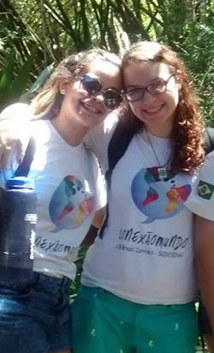Shelby, a 2014 Northwestern Michigan College fellow, shares a [presentation](http://papyruseditor.com/web/19956/USBC2014PIF) summarizing what she learned through her fellowship in Salvador, Bahia.

 “I learned a lot about leadership, coping with stress, and working with other people, but mostly, I learned about myself. This really surprised me, because I wasn't expecting any life-changing revelations on my journey to Brazil, but I actually came away knowing a lot more about myself than I did before.”

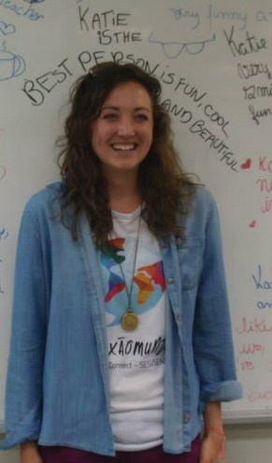

Katie, a Senior Fellow on the Community Colleges of Spokane team created this list of [tips](https://docs.google.com/document/d/1TJOYJ6wetDRX-2cuG9IAf5gJXwfAB4EMX0x1YnOm2rE/edit?usp=sharing) for fellows based on her team’s experience in Vila Velha, Espirito Santo.

“Let your team support you. Ask for what you need to be your optimal self, whether it's a talk, a run, or someone to braid your hair. You are not alone, and take advantage of the wonderful and generous people around you.”



**Blogs/Articles**

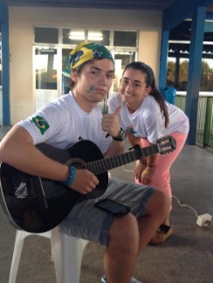Joaquin, a 2014 Miami Dade fellow shares a [reflection](https://docs.google.com/document/d/1wHNpjToyn8J8RStc6Cm0keL0qzXtB15lcqqk2OjcCBw/edit?usp=sharing) on his experience in Porto Velho, Rondonia.

“Spending so much quality time with such incredible people from a different part of the world heightened my sense of intercultural understanding.”

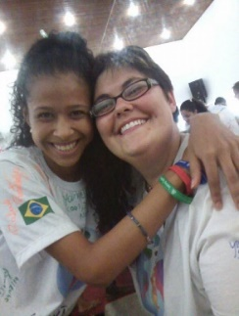

Jackie, a 2014 Kirkwood Community College fellow shares an [article](https://docs.google.com/document/d/1AiGsahUTP7WZCBlJh3Jsh4qs0-ak0qxfZIhd5vqMqRQ/edit) on her experience in Macapa, Amapa.

“We learned that our mission was more than going for the sake of coaching, it was going for the sake of engaging in an effort to connect two cultures, for the sake of preparing the next generation for future success on a global level.”

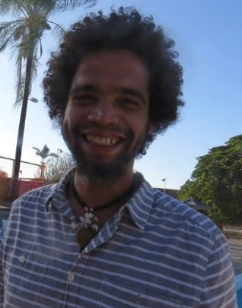

Renaissance, a 2014 Flathead Valley Community College fellow [reflects](https://docs.google.com/document/d/1SCz_Mlddp8fFA5ms6xn45HjyeJqZq5xdk77uIaUVMEo/edit?usp=sharing) on his time in Contagem, Belo Horizonte.

“The kids were the best part…Talk about life changing experiences; the first day of classes I was so nervous that I was sure to fail, but the kids don't let you. They carry you along and give you the inspiration and courage to step up and see who you can be.”

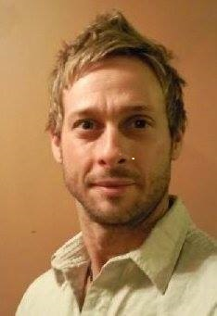

Steve, a 2014 Jackson College fellow shares [insight](https://docs.google.com/document/d/1paDFKJrmR8y3ucVgNoChhujieMAt7ShzBIy7dbYUIEM/edit) into his experience in Blumenau, Santa Catarina.

“If you are willing and able to accept this challenge, it will be an AMAZING once-in-a-lifetime life altering experience.”



**Quotes**

“I was told that this would be an once-in-a-lifetime life altering experience. And now going through it, I totally agree. The people that I've met, the relationships that I have formed, are ones I will always cherish. Traveling abroad and trying my best to make a difference in these young people's lives is something that I will never forget.”

-Jackson College Fellow

“This was one of the most positive and exciting experiences of my life. Sometimes I feel like it was all a dream. Being in Brazil felt so comfortable and yet every day I was exposed to something new to learn about the culture... It's hard to put into words, but even in just a short amount of time, I felt like I learned so much about traveling, working in a team, leading, and teaching.”

-Community Colleges of Spokane fellow

“This experience has changed my life…In working with the students and having a hand in their learning of English I learned new things about myself. That I have it in me to pursue my dreams…The students have inspired me to reach high in my life…Brazil will always and forever hold a piece of my heart.”

-Flathead Valley Community College fellow

“I experienced a new culture that gave me a new perspective on things... I learned a lot about myself and gained leadership skills, public speaking skills and traveling skills. I had to be patient, flexible and willing to do things that may have been out of my comfort zone in the US. Truth be told, I found a part of me that was hidden, and this part of me is here to stay”

-Northwestern Michigan fellow

“The benefits of participating in US-Brazil Connect’s fellowship include opportunities to develop new leadership skills, exposure to a new culture, a new way of thinking and a new way of life, forging life-long friendships and developing a broader peer network.”

-Jackson College Fellow