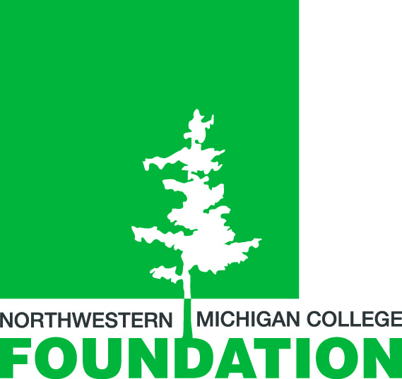
NORTHWESTERN MICHIGAN COLLEGE FOUNDATION
2013 ANNUAL NMC SCHOLARSHIP OPEN
PAYROLL DEDUCTION FORM

You are cordially invited to play in the 2013 Northwestern Michigan College Scholarship Open on Thursday, August 1, at Grand Traverse Resort. This day of fun and friendly competition provides vital support for Honors, Presidential, and Academic Area Scholarships at NMC.

Course options are the Bear or Wolverine and both courses will be playing a 4-person scramble. The special cost for NMC employees for 18 holes of golf, lunch, beverages, reception, and prizes is $175 for either Bear or Wolverine course.

Please fill out the form below to secure your place on the roster of golfers. You may pay with VISA, Mastercard, or Discover (cash and checks are welcome, too!) or by payroll deduction. Payment or payroll deduction form must be received by July 1. Please call extension 5-1021 if you have questions.

The NMC Scholarship Open Tournament Committee and the Honors, Presidential, and Academic Area scholars thank you for participating. We look forward to seeing you on
August 1.

- - - - - - - - - - - - - - - - - - - - - - - - - - - - - - - - - - - - - - - - - - - - - - - - - - - - - - - - - - - - - - - - - - -

NORTHWESTERN MICHIGAN COLLEGE FOUNDATION
2013 ANNUAL NMC SCHOLARSHIP OPEN

- I authorize the NMC Payroll Department to withhold $ per pay, for pay

periods (not to exceed 10 pays); said deduction not to exceed a total of $ ___ .

Name NMC ID
PLEASE PRINT

Office Phone #

Course: □ Bear (Scramble) □ Wolverine (Scramble)
$175 per player $175 per player
NMC employee discount NMC employee discount

Signature Date
PLEASE RETURN FORM TO THE RESOURCE DEVELOPMENT OFFICE.

THANK YOU!

